Preaching Lab Recording Instructions

Overview
These instructions document how to use the Crestron equipment to record in the preaching lab classrooms. Before beginning, be sure that you have a supply of flash drives, which you will need for storing each recording.

Recording Instructions
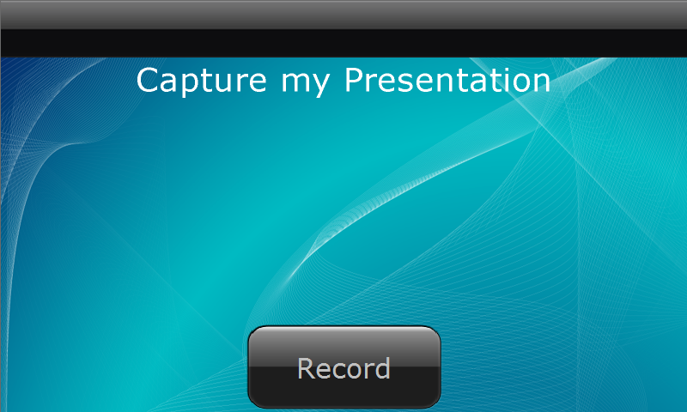
- This is the opening screen for recording a sermon or speech. Press the “Record” button to get started.

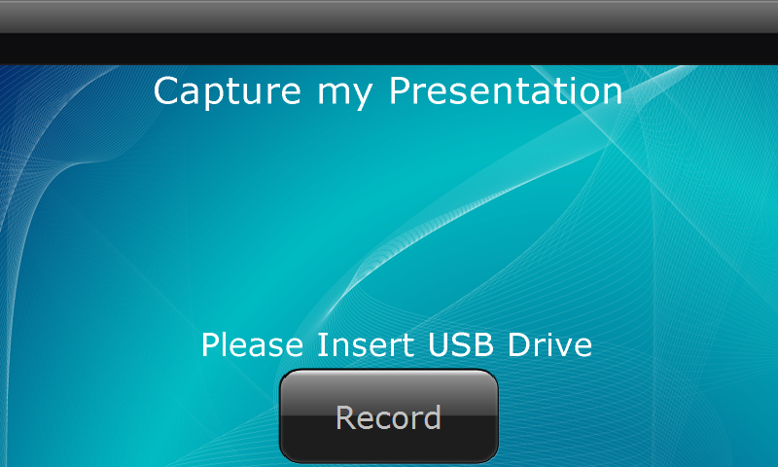
- You will be prompted to insert a USB (flash) drive if you haven’t inserted one already.

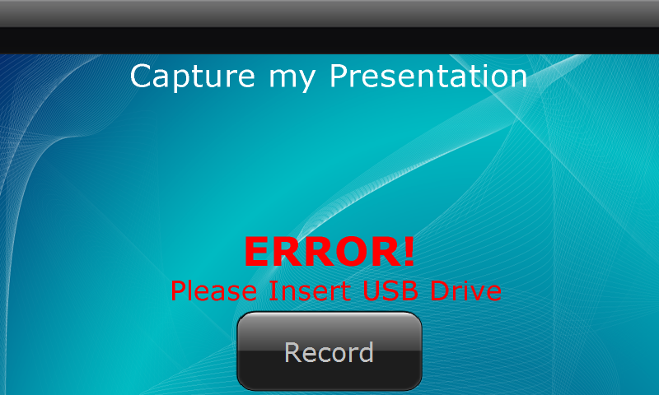
- If you try to record without inserting a USB drive, the screen will display an error message.

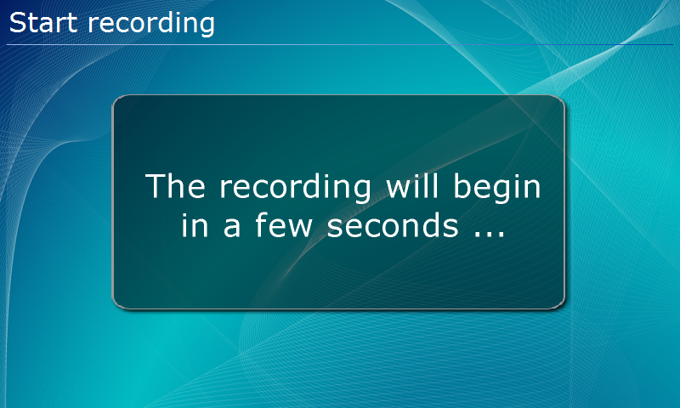
- The unit will prepare to record. The presenter will need a cue to begin when the unit starts recording.

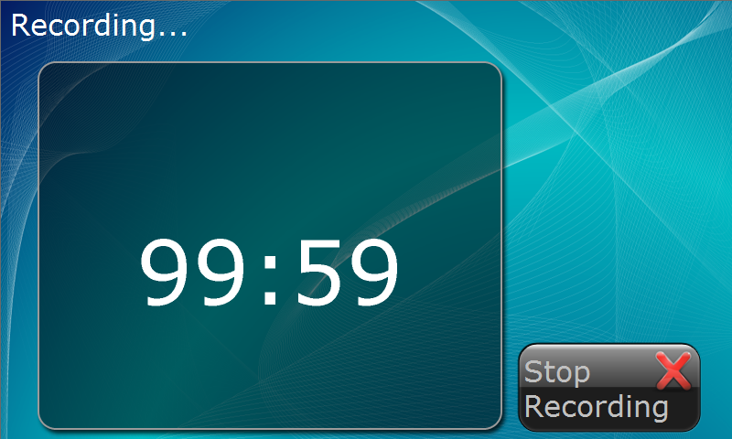
- When the recording begins, a timer will also start; click “Stop Recording” when the presenter has finished.

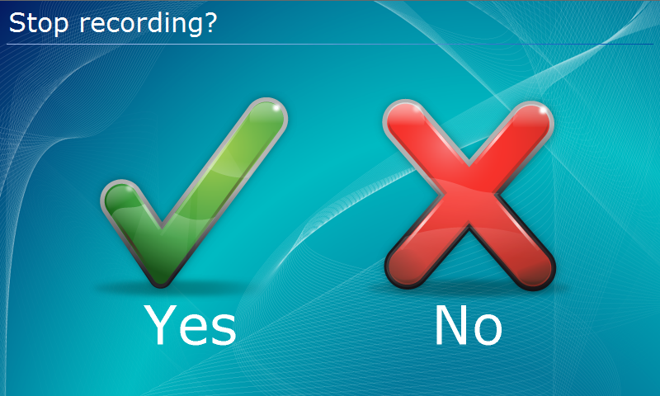
- You will be asked to confirm that you wish to stop recording; choose the appropriate response.

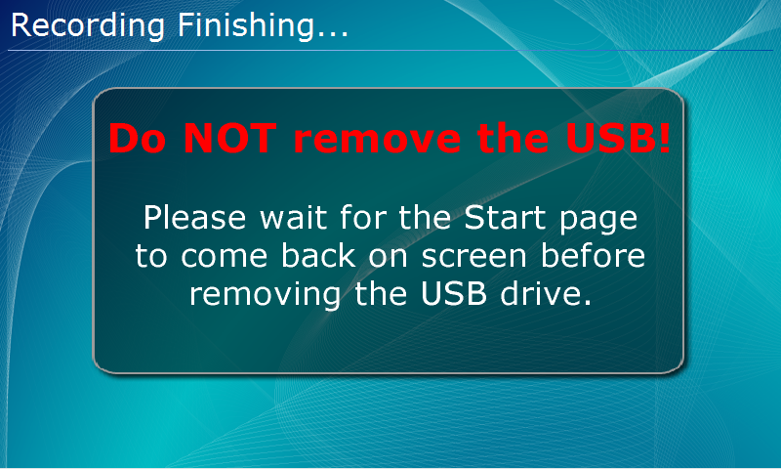
- Don’t remove the USB drive until the “Start” page is displayed again. If you remove the USB drive before this point, the entire recording will be lost.

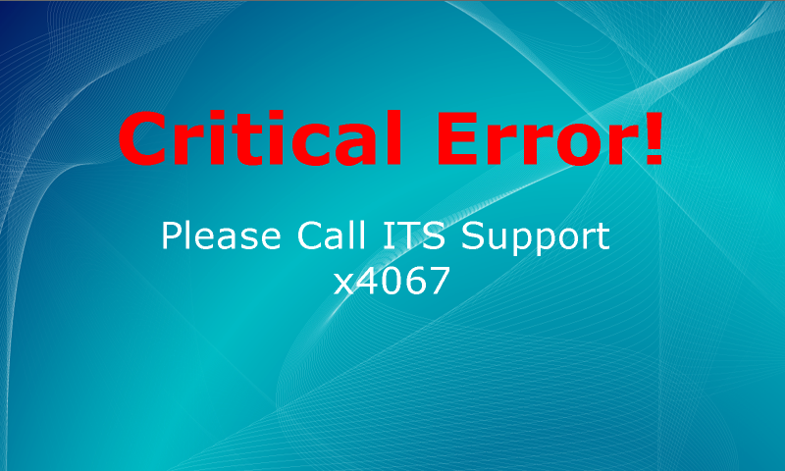
- If the “Critical Error” screen displays at any point, contact the ITS Support Center at ext. 4001.

